- Back-to-back monthly falls in GDP demonstrate the extent of the underlying weakness in the UK economy. There are strong grounds to think that activity recovered in the last couple of months of 2025. But we see the run of poor data as vindication of our weak GDP forecast for 2026, which is at the bottom of the consensus.
- This week's hearing of the Treasury Select Committee offered further evidence of the deep divisions in the Monetary Policy Committee. The most important MPC member – Governor and current swing voter Andrew Bailey – was absent. We think the MPC will narrowly vote to cut Bank Rate next week, with the lack of push back against market expectations being a key signal.
The GDP data for October was this week's only major release. We had expected a small increase in GDP that month, on the basis that manufacturing output would rebound after September's slump. But in the event, there was only a partial recovery in manufacturing production, while there was broad-based weakness across the services sector. This meant that GDP fell by 0.1% m/m for the second successive month (Chart 1).
It would be easy to overdo the gloom. But the monthly GDP data is volatile and revision-prone, and there's been a clear tendency in recent years for output to pick up around the turn of the year and strengthen markedly in Q1, which we attribute to residual seasonality in the data. We also think there's strong grounds to believe that the recovery in manufacturing output will have continued in the latter months of 2025 – we know that September's sharp drop was due to a major motor manufacturer halting production due to a cyber attack and that work restarted gradually from mid-October.
But it's clear that the underlying picture is weak. As we argued in our recent preview of the key themes likely to shape the economy in 2026, the UK lacks a sustainable growth driver, with recent growth heavily reliant on the public sector and private demand relatively weak. Our forecast for GDP growth in 2026 is at the bottom of the consensus, and today's data strengthens our belief in that call.
Chart 1: A sharp drop in services output drove October's fall in GDP
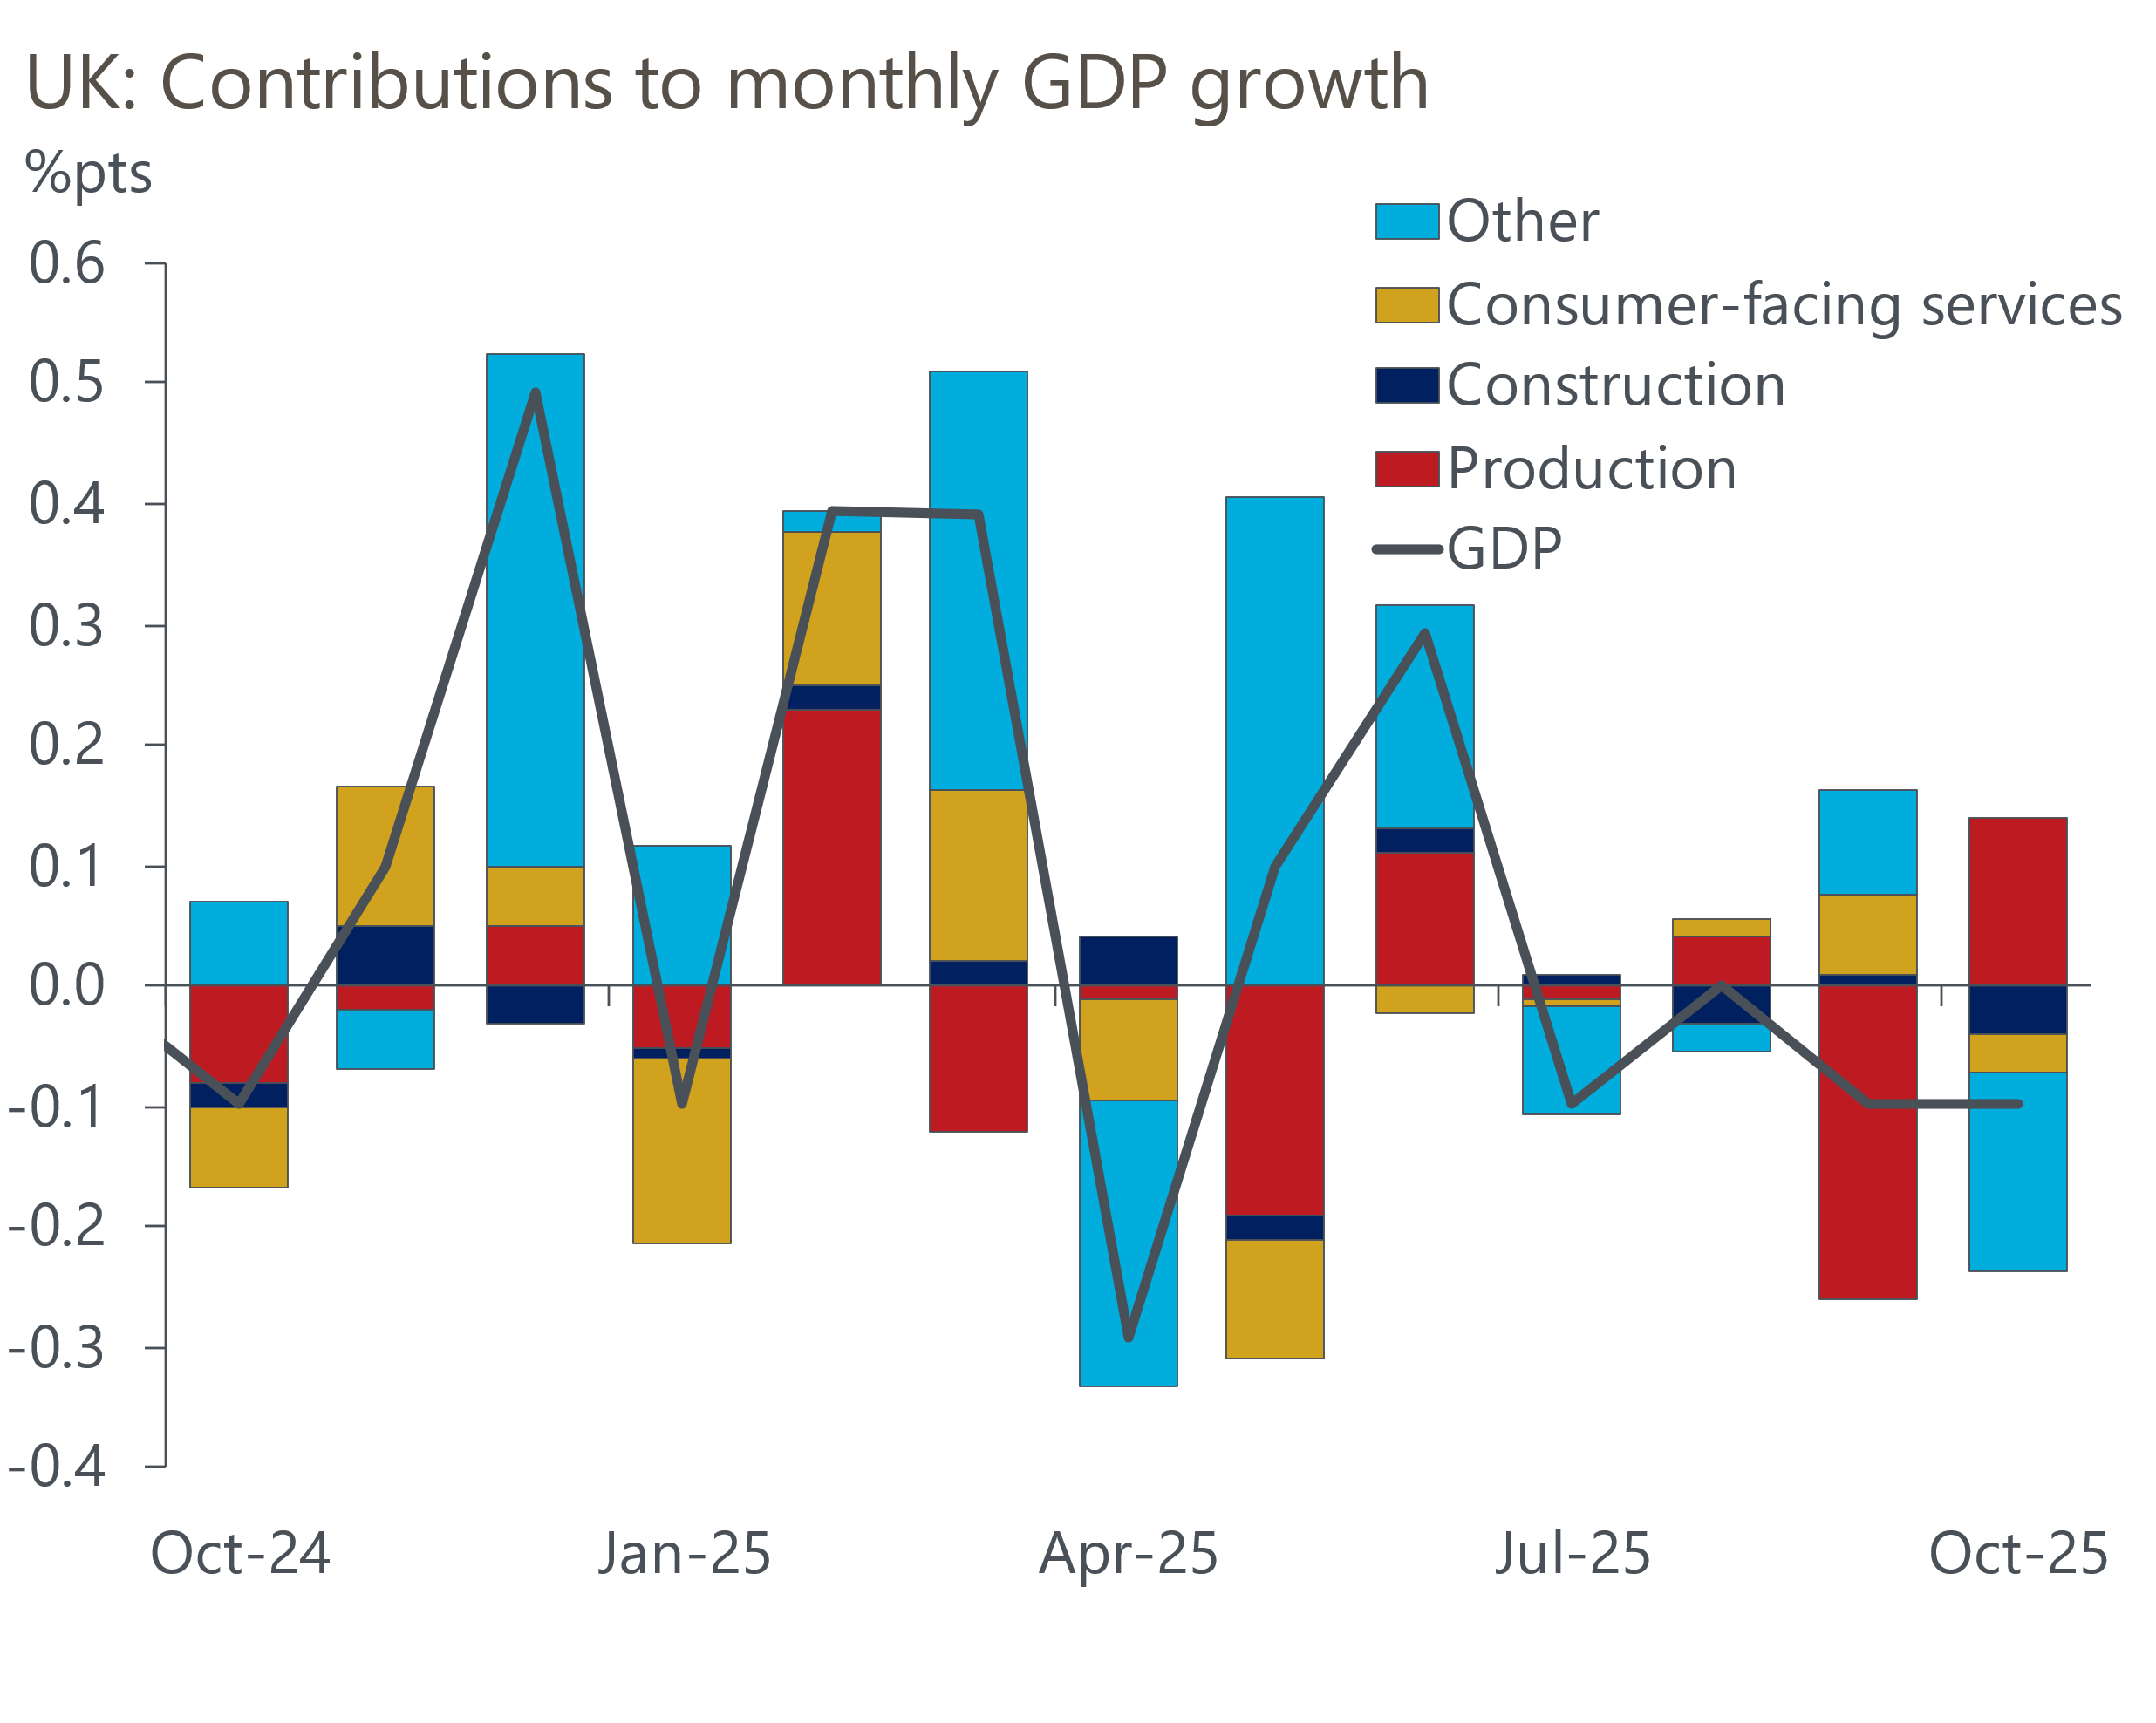
Source: Haver Analytics

Though this week's data might bolster the concerns of the doves at the margin, we doubt that it will have a material impact on next week's Monetary Policy Committee meeting. Four members of the committee gave evidence to the Treasury Select Committee this week, although unusually Governor Andrew Bailey wasn't part of the delegation. Given that Bailey has become the MPC's swing voter, it was particularly bad timing that he was absent from this evidence session.
But equally, that Bailey hasn't made any comment on monetary policy recently, when market pricing has firmed to the extent that it implies a near-90% chance of a December cut, sends its own signal. Though the data has been inconclusive since the November meeting, we think Bailey will probably prefer to support a December cut rather than go against market pricing and potentially weaken the credibility of future communications around the outlook for interest rates.
The four members who did testify were split evenly between doves (Swati Dhingra and Dave Ramsden) and hawks (Clare Lombardelli and Catherine Mann). Their testimonies were similar in substance to their individual paragraphs in the minutes of November's meeting.
One interesting nugget of information we gleaned was that Bank of England staff estimate the Budget will directly lower inflation by 0.4ppts-0.5ppts for a year from April, with a smaller impact on activity. Lombardelli noted that economic theory suggests the MPC should look through these types of temporary impacts on inflation but acknowledged that the committee hadn’t adopted this approach this year when one-off effects had pushed inflation well above the target. The generally hawkish tone of her comments gave the impression that she will look through the effects next year.
One theme that has increasingly dominated UK politics has been immigration, and data published this week suggested this topic is likely to be an increasingly important part of the economic debate in 2026. A couple of weeks ago, we noted that new population estimates from the ONS reported a sharp drop in the level of net inward migration in the year to mid-2025, to a level well below that assumed in both official population projections and the Office for Budget Responsibility's latest forecast.
Monthly data on visa applications from the Home Office suggest immigration levels have dropped further since then. In November, the number of applications for skilled worker visas fell to just 2,000, the lowest level since the current system was introduced at the start of 2022, while applications for health and care worker visas equalled October's record low (Chart 2).
Chart 2: Visa applications have dropped to very low levels in recent months
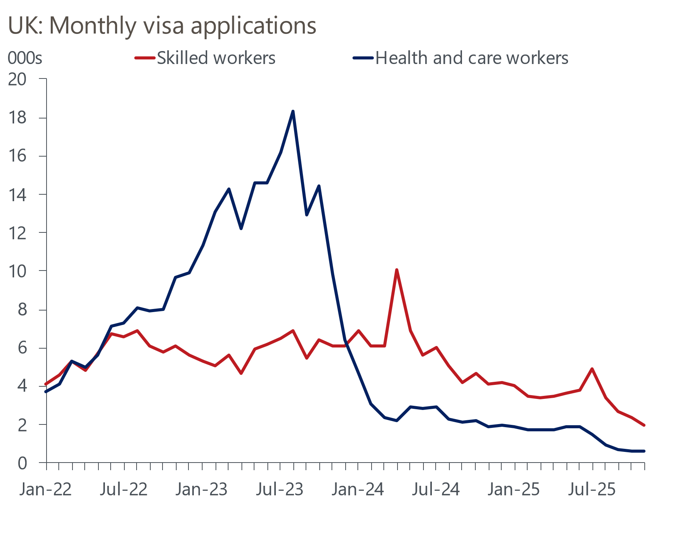
Sources: Home Office
The immigration data is only one part of the migration jigsaw, and the big slowdown in net inflows in the year to mid-2025 was partly due to higher outflows. But with the government planning further changes to immigration laws that are likely to make the UK a less attractive destination for legal migrants, it's looking increasingly likely that the official population projections will prove too high. Our forecasts are based on lower assumptions, but we will consider whether we need to lower our projections further. We plan to look at demographic developments in a series of notes in early-2026.

The week ahead
Though there's a very busy week of data releases in prospect, next week's key event will be December's Monetary Policy Committee meeting. We think the MPC will vote 5-4 to cut Bank Rate by 25bps to 3.75%, with Governor Andrew Bailey switching to vote for a cut having opted to hold in November. But while market pricing implies an almost 90% chance of a cut, we think it will be a much closer call.
One event that could throw a rate cut off course is Wednesday's inflation release. Bank of England staff expect inflation to drop to 3.4% in November, from 3.6% in October. But we think the CPI rate will hold steady at 3.6%. A marginal fall in the contribution from food prices should be offset by slightly higher services inflation, partly reflecting the comparison with a soft reading last November.
Labour market data for the August to October period should show unemployment holding steady at 5%. We think all headline (three-month average of the annual rate) measures of pay growth will have slipped back in October, with the drop in total pay being particularly large because of a spike in bonus payments last year.
After four successive monthly increases, retail sales fell by 1.1% in October. November's outturn is always particularly difficult to predict because of the growing importance of Black Friday discounting, which cause extra seasonal adjustment challenges for the ONS. But we think a recovery in food sales will drive a month-on-month increase in retail sales of 0.4%.
Table 1: Week ahead calendar
Date | Events | Period | Measure | Unit | Previous | Forecast
Dec 16 | LFS unemployment | Aug-Oct | Rate | % | 5.0 | 5.0
Dec 16 | Average earnings (total pay) | Oct | 3m, y/y | % | 4.8 | 4.3
Dec 16 | Average earnings (regular pay) | Oct | 3m, y/y | % | 4.6 | 4.5
Dec 16 | S&P Global manufacturing | Dec | PMI | % bal | 50.2 | 50.5
Dec 16 | S&P Global services | Dec | PMI | % bal | 51.3 | 52.0
Dec 16 | S&P Global composite | Dec | PMI | % bal | 51.2 | 51.9
Dec 17 | CPI inflation | Nov | m/m | % | 0.4 | 0.1
Dec 17 | CPI inflation | Nov | y/y | % | 3.6 | 3.6
Dec 17 | RPI inflation | Nov | m/m | % | 0.3 | 0.2
Dec 17 | RPI inflation | Nov | y/y | % | 4.3 | 4.4
Dec 17 | Producer input prices | Nov | m/m | % | -0.3 | 0.1
Dec 17 | Producer input prices | Nov | y/y | % | 0.5 | 0.4
Dec 17 | Producer output prices | Nov | m/m | % | 0.0 | 0.1
Dec 17 | Producer output prices | Nov | y/y | % | 3.6 | 3.2
Dec 17 | Land Registry house prices | Oct | y/y | % | 2.6 | 2.3
Dec 18 | BoE Bank Rate decision | Dec | Bank Rate | % | 4.00 | 3.75
Dec 19 | GfK consumer confidence | Dec | Headline | % bal | -19 | -17
Dec 19 | Retail sales inc fuel | Nov | m/m | % | -1.1 | 0.4
Dec 19 | Retail sales inc fuel | Nov | y/y | % | 0.2 | 1.0
Dec 19 | Public finances | Nov | PSNB ex | £bn | 17.4 | 10.0
Source: Oxford Economics

Key forecasts
Table 2: UK forecast overview
(Annual percentage changes unless specified)
 | 2023 | 2024 | 2025 | 2026 | 2027 | 2028
GDP | 0.3 | 1.1 | 1.4 | 1.0 | 1.4 | 1.5
Private consumption | -0.3 | -0.2 | 0.9 | 1.0 | 1.1 | 1.4
Fixed investment | 0.5 | 1.8 | 3.0 | 0.9 | 2.1 | 2.1
Government consumption | 2.1 | 3.4 | 2.0 | 2.0 | 1.7 | 1.4
Exports of goods and services | -2.3 | 0.6 | 2.8 | -0.4 | 1.0 | 1.3
Imports of goods and services | -1.6 | 2.6 | 3.6 | -0.4 | 1.2 | 1.4
Industrial production | -2.6 | -1.6 | -0.5 | -0.1 | 1.1 | 1.3
Consumer prices | 7.3 | 2.5 | 3.4 | 2.7 | 2.5 | 2.2
Unemployment rate (%) | 4.1 | 4.3 | 4.8 | 5.0 | 4.8 | 4.5
Current a/c balance (% of GDP) | -3.6 | -2.2 | -3.0 | -2.7 | -2.6 | -2.5
Government balance (% of GDP) | 5.2 | 5.2 | 5.0 | 3.9 | 3.3 | 2.8
Central bank policy rate (%, EOP) | 5.25 | 4.75 | 3.75 | 3.25 | 3.00 | 2.75
10yr govt. bond yield (%, EOP) | 3.54 | 4.57 | 4.60 | 4.39 | 3.89 | 3.65
Exchange rate (US$ per £, EOP) | 1.27 | 1.25 | 1.32 | 1.29 | 1.29 | 1.29
Exchange rate (euro per £, EOP) | 1.15 | 1.21 | 1.14 | 1.11 | 1.11 | 1.11
Source: Oxford Economics
Table 3: Quarterly forecasts for the UK
 | 2025 |  |  |  | 2026
 | Q1 | Q2 | Q3 | Q4 | Q1 | Q2 | Q3 | Q4
GDP (% year) | 1.8 | 1.4 | 1.3 | 1.2 | 0.8 | 0.8 | 1.0 | 1.2
CPI inflation (% year) | 2.8 | 3.5 | 3.8 | 3.6 | 3.4 | 2.4 | 2.5 | 2.5
Bank Rate (%, EOP) | 4.50 | 4.25 | 4.00 | 3.75 | 3.75 | 3.50 | 3.50 | 3.25
10yr gilt yield (%, EOP) | 4.70 | 4.48 | 4.70 | 4.60 | 4.60 | 4.57 | 4.49 | 4.39
US$ per £ (EOP) | 1.29 | 1.37 | 1.35 | 1.32 | 1.30 | 1.29 | 1.29 | 1.29
Euro per £ (EOP) | 1.20 | 1.17 | 1.15 | 1.14 | 1.12 | 1.11 | 1.11 | 1.11
Source: Oxford Economics

Latest Country Economic Forecast:
December 10, 2025

Recent publications

Data Insights
Successive monthly falls in GDP highlight underlying weakness
PMI points to an economy that is muddling along
Mortgage market firms up after Stamp Duty change
Pre-Budget concerns weigh on the PMI
October's drop in retail sales shouldn't be a source of concern

Research Briefings
MPC preview – Close call, but probably a cut
Why are household savings higher? Evidence from microdata
Key themes 2026 – Sluggish growth and fiscal worries
Budget papers over the cracks but can't hide the fiscal risks
Better affordability puts housing market on firmer footing

Contacts

Oxford Economics' UK team
- Andrew Goodwin - Chief UK Economist - agoodwin@oxfordeconomics.com
- Edward Allenby - Senior UK Economist - eallenby@oxfordeconomics.com

